CIVIC SERVICES PLATFORM: COMPLAINT MANAGEMENT SYSTEM
MILESTONE 3
Course: Software Engineering
Team 107
Team Members | Student ID
Anusha Murthy | 21f1006306
Paramveer Singh | 21f1006266
Utkarsh Omre | 23f3000151
Someshwar Srimany | 21f1002093
Shahzada Moon | 23f2002668
Ritesh Kumar Jha | 23f3002470


IITM Online BS Degree Program,
Indian Institute of Technology, Madras, Chennai
Tamil Nadu, India, 600036
1

Table of Contents
1. Executive Summary 2
2. Project Background and Problem Statement 3
3. User Research and Identified Requirements 4
3.1 Users identified 4
3.2 Pain points → what the final system does about them 4
3.3 Functional requirements — traceability 4
3.4 User Stories 5
4. System Design and Architecture 6
5. Project Schedule, Sprints & Workflow 8
6. Technologies and Tools Used 9
7. Implementation Details 10
8. Testing & Quality Assurance 11
8.1 From Milestone 3 to Milestone 5 11
8.2 Current suite — 113 tests, 100% passing 11
9. Issue Tracking, Code Review and Project Management 12
10. Instructions to run the application 13
Backend 13
Frontend 13
Test suites 14
Demo accounts (mock mode, password mock) 14
11. Conclusion and Future Enhancements 14

1. Executive Summary

The Civic Services Platform is an Intelligent Complaint Management System for civic problems — waste, water, roads, lighting, drainage, and parks. It was built across five milestones to solve the problem identified in Milestone 1: citizens reporting the same issue multiple times with no visibility into progress, and authorities struggling to prioritise and de-duplicate complaints coming from scattered channels.
The system implements three roles with no role-switching — a citizen registers and tracks their own complaints, a field officer works a priority queue scoped to their own department, and the municipal chairman sees everything, including administration. In the shipped product, this is branded CivicConnect (the in-app name visible on the sign-in screen and browser tab), while this report refers to the project by its formal title throughout.

By Milestone 5 the system is a complete, working prototype: a Flask + SQLAlchemy REST API backed by SQLite, a Vue 3 + TypeScript frontend that runs against either an in-memory mock dataset or the live API behind a single switch, automatic complaint deduplication and priority scoring, role-scoped API responses so internal fields never reach a citizen, an append-only audit log for every privileged action, and an automated test suite of 113 tests (60 backend, 53 frontend), all passing.

Metric | Value
Roles | 3 (Citizen, Field Officer, Chairman)
Database tables | 13
Frontend pages | 21
Pull requests opened | 39
Inline code-review comments | 37
Automated tests | 113 (100% passing)

Every functional requirement (FR-01–FR-10) and every user story (US-01–US-12) identified in Milestone 1 has been implemented against this final system — traced in detail in Section 3.

2. Project Background and Problem Statement

Civic complaints — garbage accumulation, road damage, water leakage, drainage issues, broken streetlights — are common in urban areas, but citizens routinely struggle to report them and, once reported, to find out what happened next. A recurring failure mode surfaced in early research: several citizens report the same underlying issue independently, which multiplies workload for municipal staff without multiplying information, and makes it harder, not easier, to see which problems are actually urgent.

Existing civic complaint handling lacks transparency, proper tracking, and efficient triage. Citizens do not reliably know whether a complaint was accepted, who is working on it, or when it will be resolved. Authorities receive complaints from multiple, uncoordinated channels and end up treating duplicates as separate tickets, which creates redundant dispatch and makes prioritisation difficult.

CivicConnect was scoped to close that gap directly: detect duplicate or similar complaints and group them under one ticket, prioritise automatically using a transparent, tunable formula, keep citizens informed without them having to ask, give every ticket a named accountable officer, and give the chairman a live, city-wide view instead of a delayed, manual one.

3. User Research and Identified Requirements
Carried forward unchanged from Milestone 1, and traced against the final implementation.

3.1 Users identified
Tier | User | Description
Primary | Citizen | Registers complaints, tracks status, receives updates, provides feedback
Secondary | Field Officer | Handles assigned complaints, updates progress, submits resolution proof
Tertiary | Municipal Commissioner / Chairman | Reviews department performance and city-wide complaint trends

3.2 Pain points → what the final system does about them
Pain Point | Affected Users | Resolved by
Duplicate complaints | Citizens & Field Officers | engine.py deduplication — radius + similarity match, joins an existing ticket
No similar-ticket mapping | Field Officers | Complaints link to one Ticket via ComplaintTicketLink; report count rises instead of a new ticket opening
Lack of complaint tracking | Citizens | Citizen timeline screen (/complaint/:id) with live status
No officer details | Citizens | Assigned officer name surfaced on the citizen-facing ticket detail
Manual prioritisation | Field Officers | engine.compute_score() — weighted severity, report count, days open, officer availability, context
No feedback option | Citizens & Chairman | Post-resolution rating (/complaint/:id/rate), feeds the chairman's performance screen
Delayed complaint monitoring | Chairman | City overview, SLA config with live breach detection, audit log

3.3 Functional requirements — traceability
ID | Requirement | Status
FR-01 | Citizens submit complaints with category, location, description, images | ✅ Implemented (ReportIssue.vue, voice-recording input also added)
FR-02 | System detects duplicate/similar complaints | ✅ engine.py, lexical + optional embedding similarity
FR-03 | Similar complaints mapped to one main ticket | ✅ ComplaintTicketLink
FR-04 | Automatic prioritisation by severity, report count, location, pending time | ✅ PriorityScore, configurable weights
FR-05 | Officers view assigned complaints by priority | ✅ /officer/queue, sorted by score
FR-06 | Officers update status and upload completion evidence | ✅ status-update + resolve endpoints, proof photos
FR-07 | Citizens track complaint status | ✅ citizen timeline
FR-08 | Citizens see officer/team with contact details | ✅ officer card on ticket detail
FR-09 | Citizens provide feedback after resolution | ✅ rating + comment, reopens on poor rating
FR-10 | Chairman views dashboards for priority, duplicates, delays, feedback | ✅ full chairman console (Section 4)

3.4 User Stories
ID | Story
US-01 | As a citizen, I want to submit a complaint with location, category, description, and images, so officers have enough information to act without following up with me.
US-02 | As a citizen, I want to track my complaint's status throughout its lifecycle, so I stay informed without contacting the field officer.
US-03 | As a citizen, I want to see the officer working on my complaint with contact details, so I can hold someone accountable.
US-04 | As a citizen, I want to give feedback after resolution, so poor resolutions are flagged and I don't have to re-file.
US-05 | As a field officer, I want to view assigned complaints with location and description, so I arrive prepared.
US-06 | As a field officer, I want complaints ordered by priority, so critical issues don't wait behind low-priority ones.
US-07 | As a field officer, I want to upload photos after completing work, so it's documented and I'm protected against false re-complaints.
US-08 | As a field officer, I want similar complaints grouped under one ticket, so duplicate work is reduced.
US-09 | As a field officer, I want to see how many citizens reported the same issue, so I can weigh how many residents are affected.
US-10 | As the chairman, I want to see high-priority and delayed complaints, so urgent issues get monitored.
US-11 | As the chairman, I want to see duplicate complaint clusters, so I can identify problem areas and allocate resources proactively.
US-12 | As the chairman, I want to review citizen feedback and officer performance, so service quality improves.

4. System Design and Architecture

The Database Design Diagram, as submitted previously, illustrates the structure of the application's database, including entities, attributes, primary keys, foreign keys, and their relationships. It ensures efficient data organisation, minimises redundancy, and supports reliable data storage and retrieval for the system.
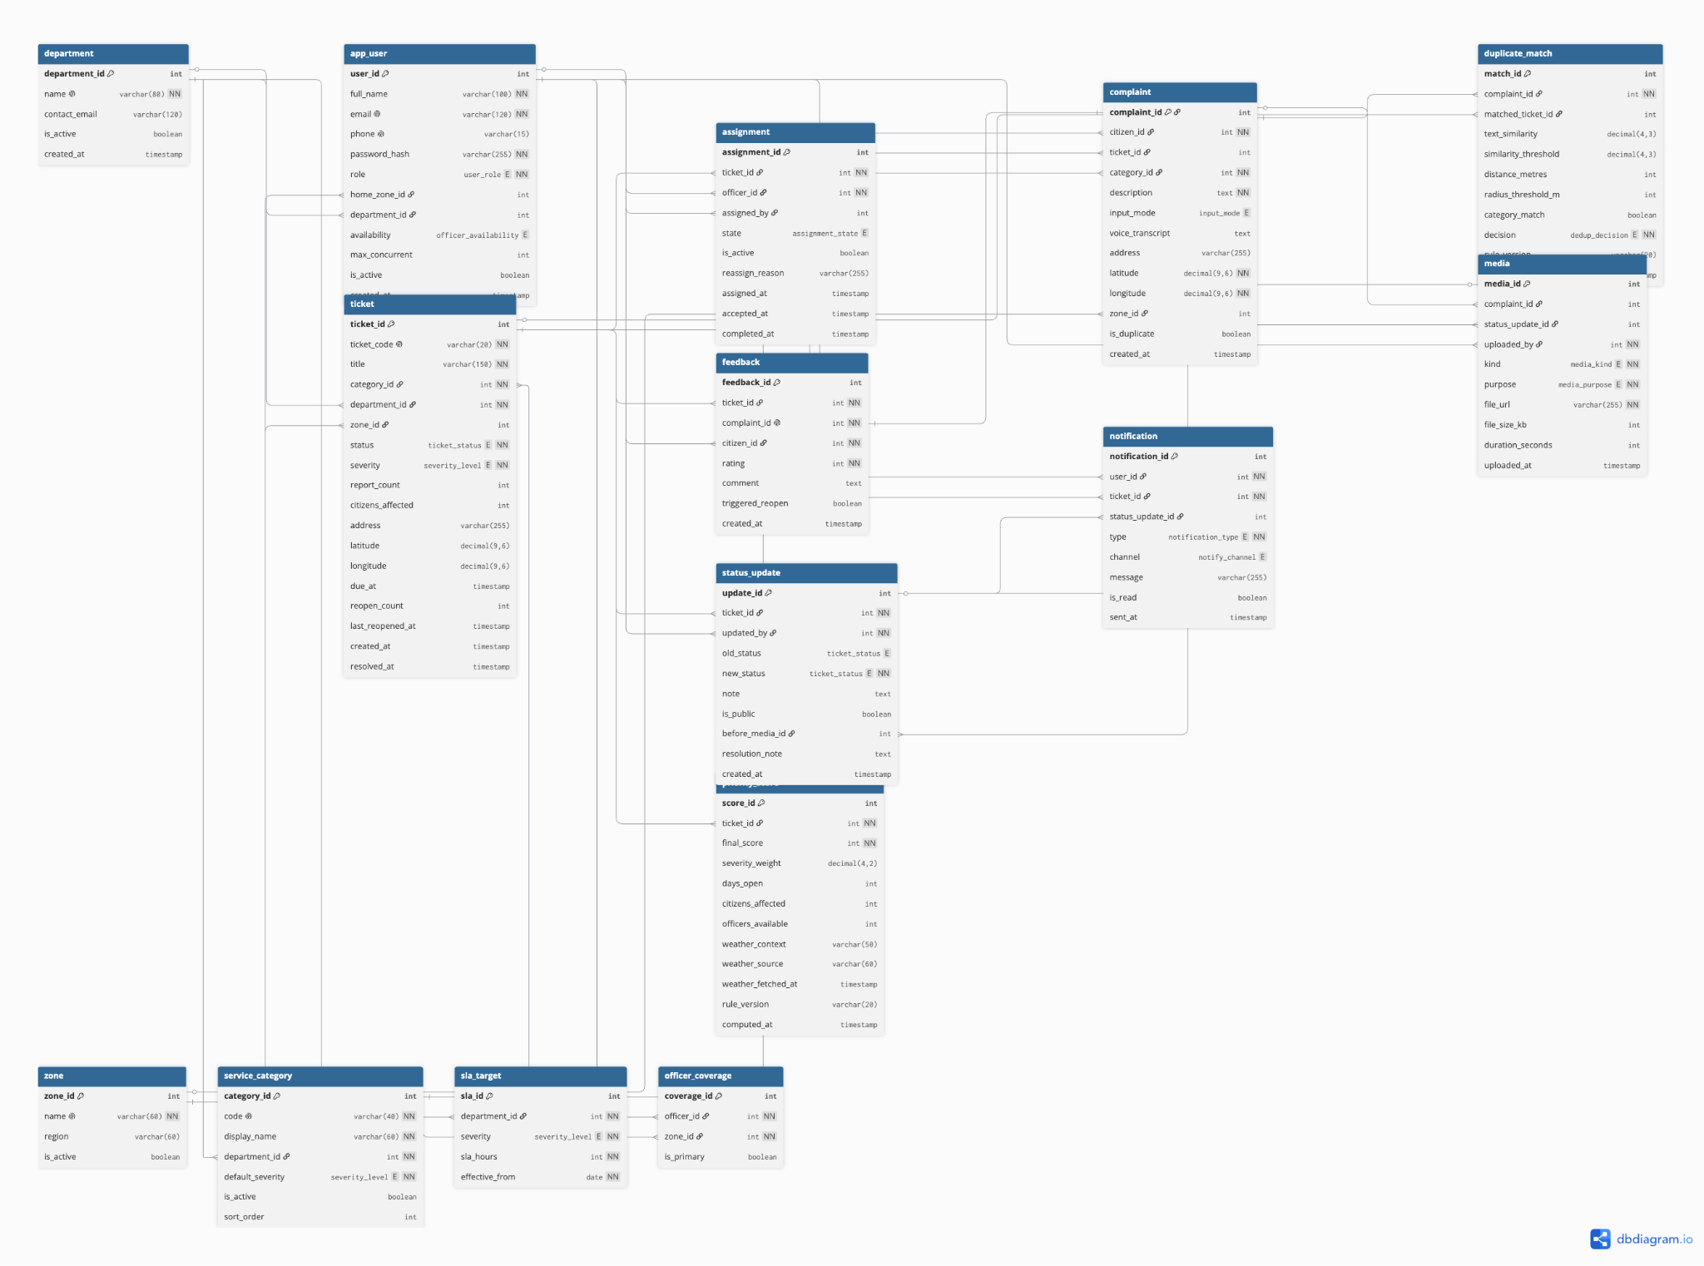

The Class Diagram provides a visual representation of the system's object-oriented structure. It illustrates the classes, their attributes, methods, and the relationships between them, such as inheritance, association, and aggregation. This diagram acts as a blueprint for the application's software design and implementation.
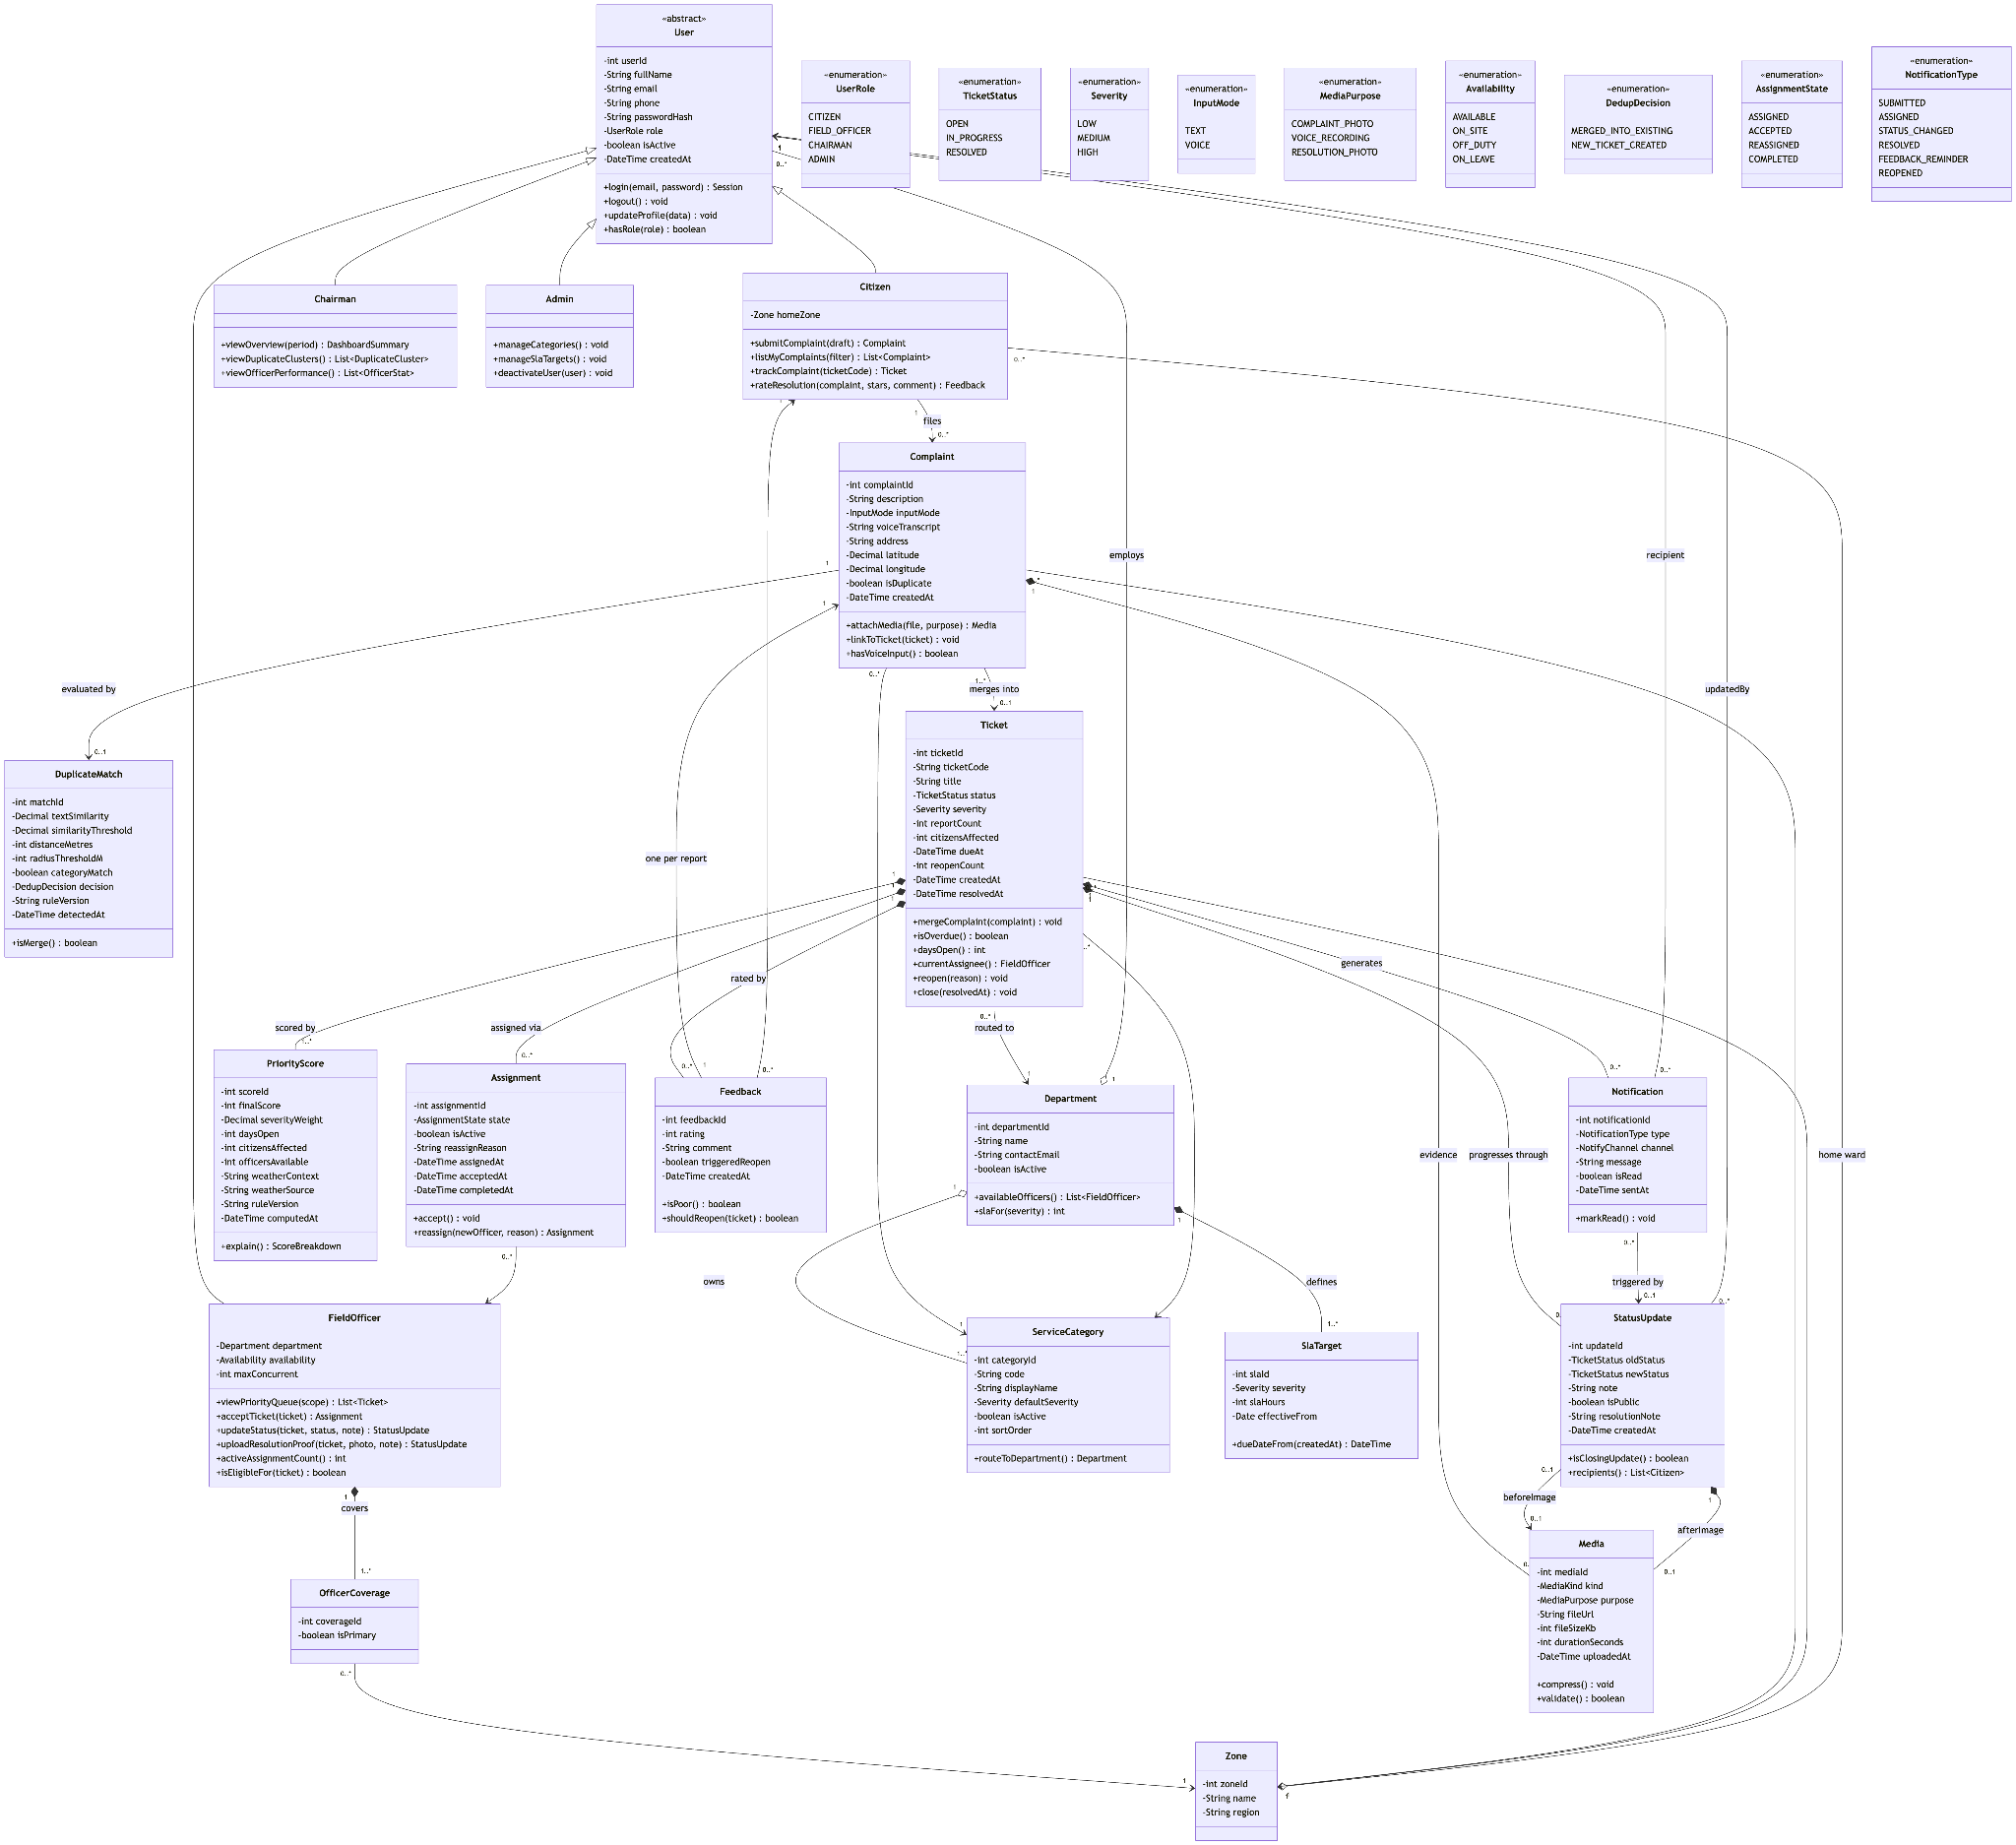

5. Project Schedule, Sprints & Workflow

High-Level Timeline:

Milestone 1 : 28th June
Milestone 2 : 23rd July
Milestone 3 (Sprint 1) : 3rd August
Milestone 4 (Sprint 2) : 12th August
Milestone 5 : 23rd August

Scrum Practices
All milestones were tracked and maintained on Jira. Jira was also the task management tool used to keep track of features.

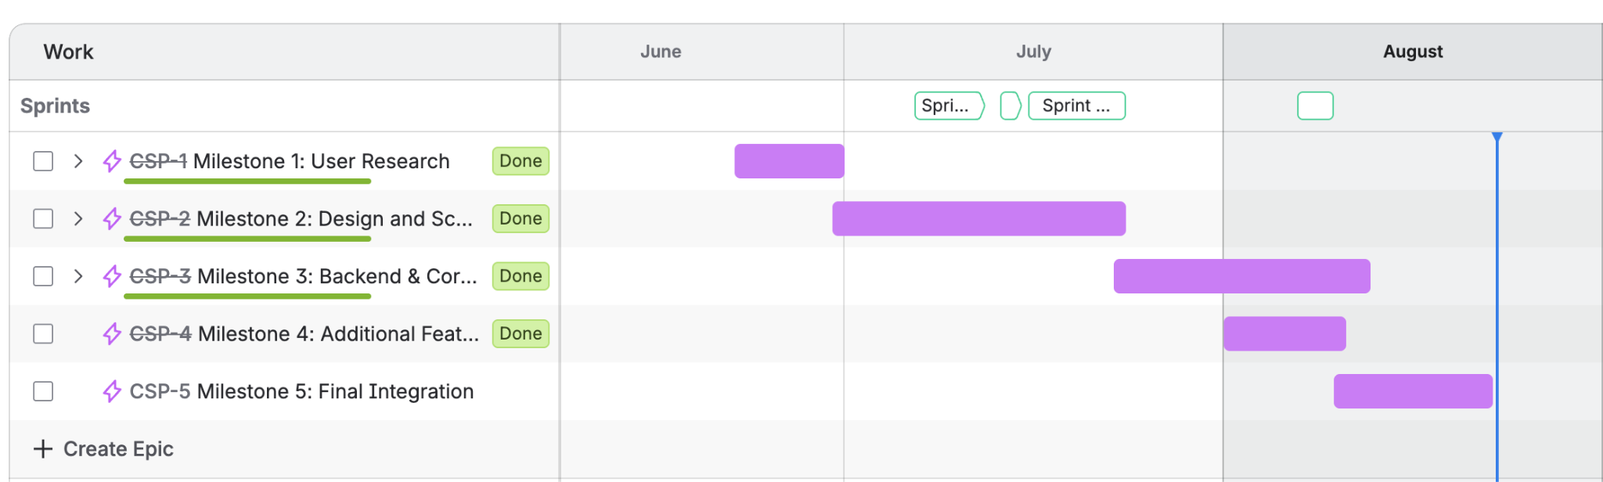

A weekly check-in review meeting was held to track progress and discuss updates.

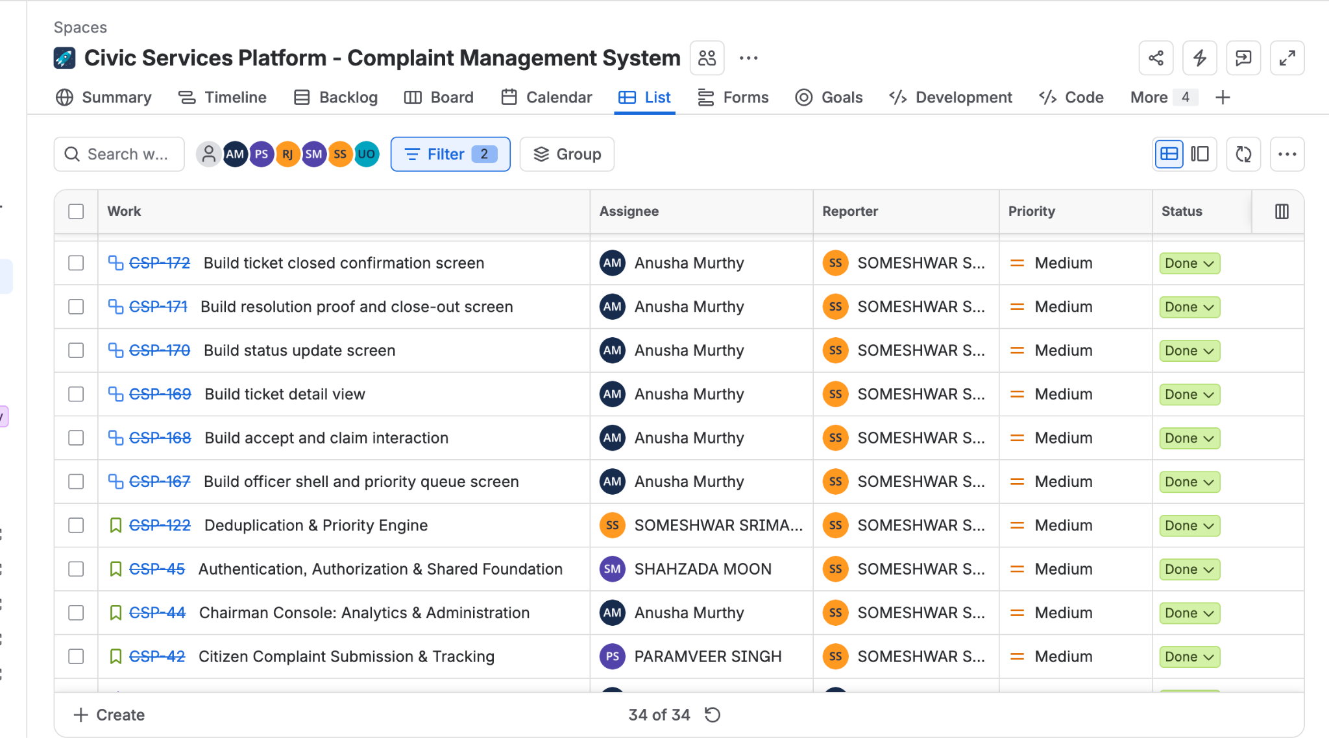

6. Technologies and Tools Used
Frontend
- Vue 3 + Vite, TypeScript, Vue Router 4
- Vitest + @vue/test-utils + jsdom for component/service tests

Backend
- Flask 3.1 + Flask-SQLAlchemy 3.1.1 + SQLAlchemy 2.0.36, Flask-Cors 5.0
- PyJWT 2.10.1 for token issuance/verification
- SQLite for local development
- pytest for the backend test suite
- Optional local LLM via Ollama (qwen2.5) for duplicate-similarity scoring and ticket titling — off by default, with a token-overlap fallback when unavailable

Development & management tools
- Git + GitHub, with CSP-prefixed tickets tracked as feature branches and reviewed pull requests
- OpenAPI 3.0.3 / Swagger specification for the backend surface
- Jira for task management

7. Implementation Details

Citizen

Self-registration with email verification; password reset. Reporting an issue is one screen with a review step, not two — going back to edit keeps the form state, nothing is thrown away. Submission carries an idempotency key, so a retried request after a timeout returns the original complaint instead of filing a second one. A citizen sees only their own complaints, filterable by status, each with a status timeline, assigned officer, and resolution proof; they rate the fix once it's closed.

Field Officer

A ranked queue (mine, or the whole department), scoped so an officer can only see and act on their own department's tickets. Two officers can press accept on the same ticket at the same moment; a unique index on the assignment table lets the database decide, not request order — one officer gets it, the other gets a conflict and a refreshed queue. Status updates carry a citizen-visible note and, like close-outs, an idempotency key so a retried submission doesn't append twice to the log.

Municipal Chairman

Screen | Capability
/chairman | Counts, average resolution time, high-priority and delayed cases
/chairman/clusters | Where reports pile up — map or list
/chairman/dedup | Why complaints were grouped, and detaching a wrong match
/chairman/performance | Ratings and per-officer figures
/chairman/scoring | Priority-score weights and duplicate-matching thresholds
/chairman/sla | Days-to-resolve targets by severity
/chairman/officers | Create, move, and deactivate officers
/chairman/audit | Every privileged write, append-only

Deduplication and priority scoring

A new complaint is compared against open tickets in the same category within a radius. Above a configurable similarity threshold, it joins the existing ticket and the report count increases; below it, a new ticket opens. Every decision is stored with its score, candidate ticket, and the threshold in force at the time, so the chairman can audit why two complaints were or weren't merged. Priority is a weighted sum of severity, report count, days open, officer availability, and context; weights live in runtime configuration, not code, so the chairman changes them without a redeploy, and identical inputs always score identically.

Access control and the error contract
Role and department guards sit in security.py and are enforced server-side on every route, not just hidden in the UI — a citizen or officer session calling a chairman endpoint gets INSUFFICIENT_ROLE, not a silently empty response. Every failure across the API returns the same closed-set shape ({ "error": { "code", "message", "details" } }), which the frontend maps to role-appropriate copy the user can act on.

8. Testing & Quality Assurance

8.1 From Milestone 3 to Milestone 5
Milestone 3 shipped a 23-test pytest suite against the early backend prototype: 19 passed, 4 failed — and those 4 failures were documented as pre-existing test-assertion bugs, not API defects, with the report explicitly showing the mismatch (e.g. test_overview_counts asserting counts.open == 3 when its own comment and the seed data said 2). That practice — showing a real test failure and explaining root cause rather than hiding it — is one this team kept using: two similar test-assumption mismatches were found and documented while building this milestone's suite (see Section 11).

8.2 Current suite — 113 tests, 100% passing
Area | Backend (pytest) | Frontend (Vitest) | Covers
Citizen portal | 12 | 7 | Submission validation, idempotent retries, citizen-safe projections, cross-citizen isolation, timeline, rating rules
Deduplication | 12 | 10 | Linking, the three ways a complaint stays separate, decision records, score effects, unmerge, threshold changes
Complaint list UI | — | 4 | Loading, populated, empty states
Officer console | 16 | 15 | Queue scoping, claim + conflict, department-scope guards, auto-claim, resolve validation, summary counts
Chairman console | 20 | 17 | Overview + filters, priority sort, clusters, reassign/escalate + audit, SLA/scoring validation and live re-scoring, audit filters, officer CRUD
Total | 60 | 53 | 113 tests, 100% passing
Backend and frontend suites assert the same business rules independently — pytest runs a real Flask app against a throwaway SQLite file per test; Vitest runs against services/mock.ts with no backend or browser. Where the two would otherwise drift, that drift shows up as a failing test on one side, which is exactly how this suite surfaced two real inconsistencies during development before they could reach either console.

9. Issue Tracking, Code Review and Project Management

Issue tracking on GitHub: Work items were tracked as tickets, each given its own branch rather than worked directly on a shared branch. This keeps each change reviewable and revertible in isolation.

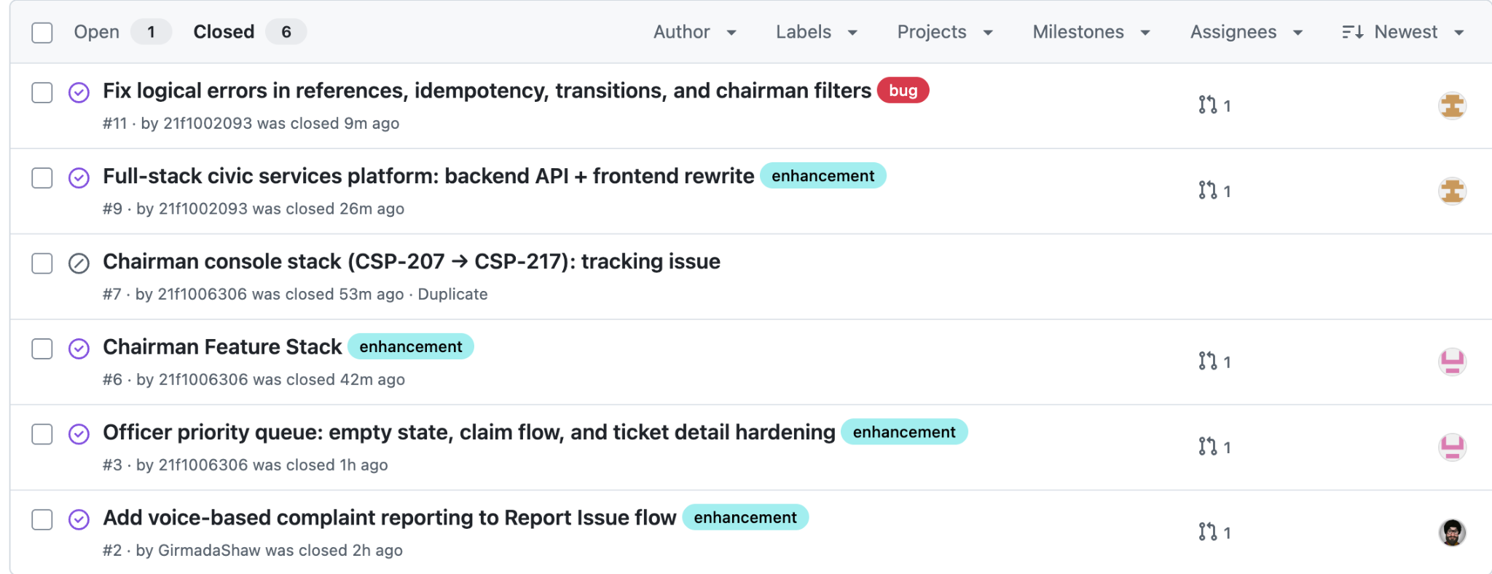
Code reviews on Github: Substantive changes went through pull requests before merging into the integration branch — the merge history shows PR-numbered merges rather than direct pushes, consistent with a review-before-merge policy.

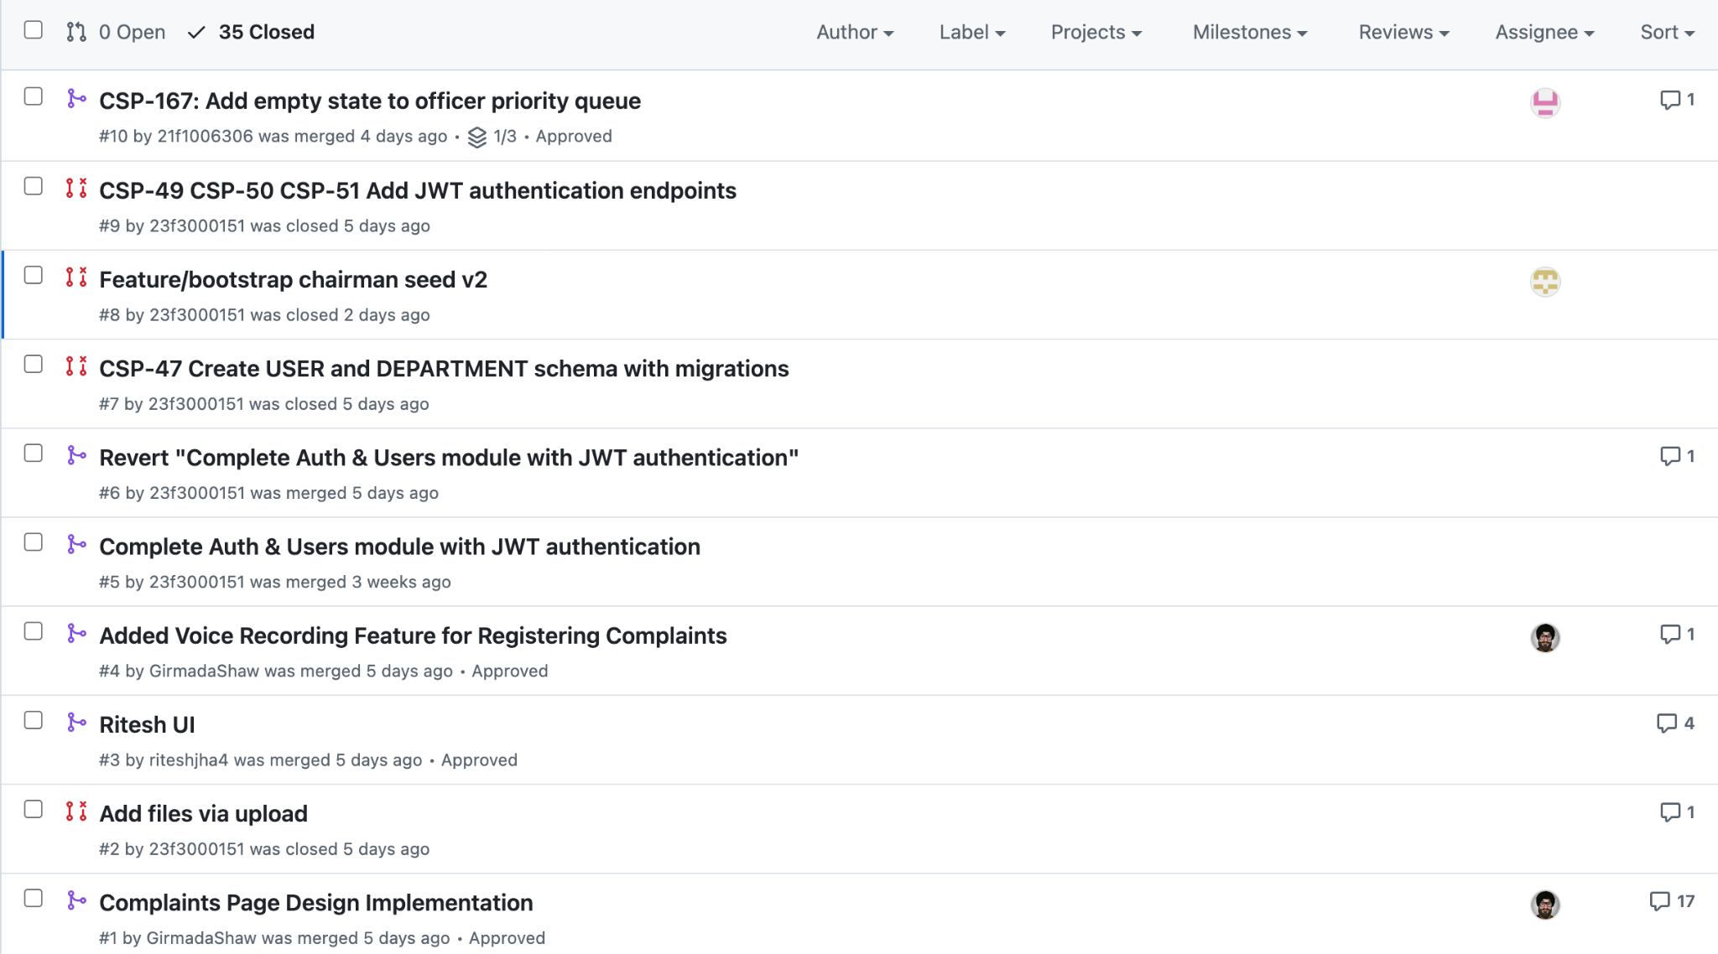

10. Instructions to run the application

Backend
cd backend
python3 -m venv .venv
./.venv/bin/pip install -r requirements.txt
./.venv/bin/python seed.py --demo
./.venv/bin/python run.py
Serves on http://localhost:5001; the API lives under /api/v1. seed.py alone creates departments, categories, and the first chairman; --demo adds officers, citizens, and sample complaints. Both are safe to re-run.

Frontend
cd frontend
npm install
npm run dev # mock data, no backend needed
npm run dev:live # talks to the backend on port 5001
Opens on http://localhost:5173. Requires Node 20.19+ or 22.12+.

Test suites
# Backend
cd backend && ./.venv/bin/pytest -q

# Frontend
cd frontend && npm run test

Demo accounts (mock mode, password mock)
citizen@mock.local
officer@mock.local
chairman@mock.local


11. Conclusion and Future Enhancements
The Civic Services Platform delivers, end to end, on the problem identified in Milestone 1: duplicate complaints are detected and grouped automatically, citizens get real status visibility, officers get a prioritised and safely-claimable queue, and the chairman gets city-wide oversight with a full audit trail. Every functional requirement and user story from Milestone 1 is implemented and covered by the 113-test automated suite.
Known gaps, honestly stated, to carry forward:
- No formal end-user testing round has been conducted yet (flagged in Section 8.3) — the clearest next step before treating this as production-ready.
- No CI pipeline currently runs the test suite automatically on push; tests are run locally.
- Semantic (embedding-based) deduplication via the local LLM is implemented but off by default — lexical similarity is what runs in practice.
- Resolution-photo storage is reference-only (media IDs), not backed by real object storage.
Possible future enhancements:
- Wire up CI so the 113-test suite runs on every PR automatically.
- Complete a real end-user testing round with citizens and field officers.
- Evaluate enabling the embedding-based similarity provider by default once Ollama availability can be guaranteed in deployment.
- Add real file storage for resolution proof photos.

